CHAPTER 6
WIRELESS VULNERABILITY TESTING

1. Verify Wireless card
The first thing we have to do is to check if we have the wifi card connected or not. Type the command "iwconfig" in the terminal and you will get all the connected wireless networking devices.

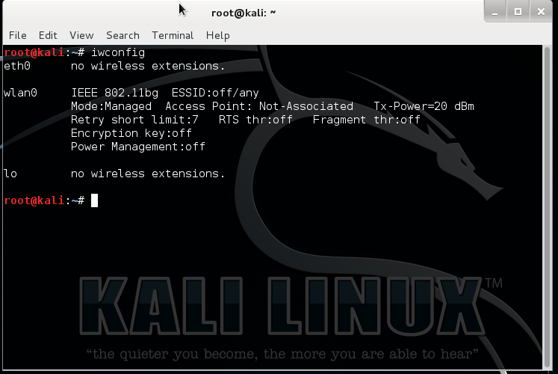

Figure 6-1:iwconfig command output

We can also check by typing "ifconfig -a". This gives a total description of all the networking devices connected.

2. activate the monitor mode on the card
After checking the card for connection and noting the name of the card, next we have to put it into monitor mode. Monitor mode can be activated with airmon-ng.
Use command airmon-ng start wlan0, since the network we are going to use has the name wlan0.

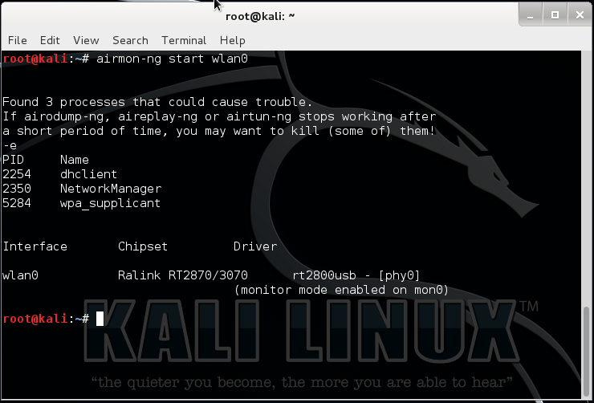

Figure 6-2: setting the card to monitor mode.

This creates a new virtual interface called mon0. Can check with “iwconfig” command.

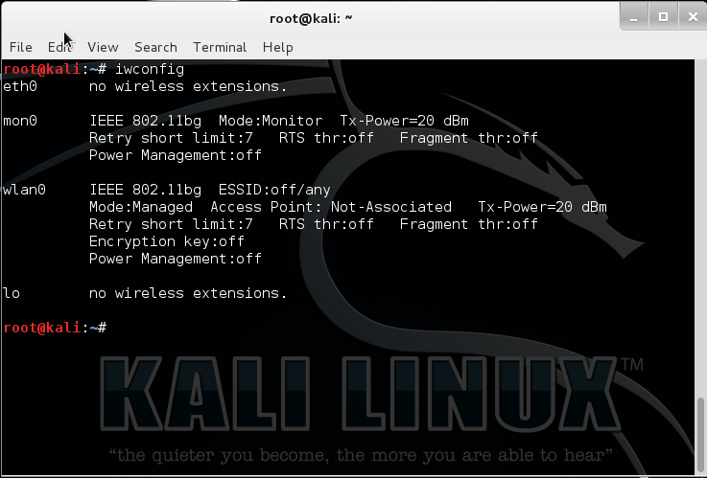

Figure 6-3: checking the monitor mode instance.

3. scan all wifi networks
Wi-Fi uses radio and like any radio it needs to be set to a certain frequency. Wi-Fi uses 2.4GHz and 5GHz (depending on which variation you are using). The 2.4GHz range is split into a number of “channels” which are 5MHz apart. To get two channels which don’t overlap at all they need to be spaced around 22MHz apart (but that also depends on which variation of the Wi-Fi standard is being used). That is why channels 1, 6 and 11 are the most common channels as they are far enough apart so that they don’t overlap.
To capture data via a Wi-Fi adapter in “monitor” mode you need to tell the adapter which frequency to tune into, i.e. which channel to use. To see which channels are in use around you and which channel is being used by the target Wi-Fi service you wish to test then use the airodump-ng command.
Use airodump-ng mon0 command , since the network instance created here is mon0.
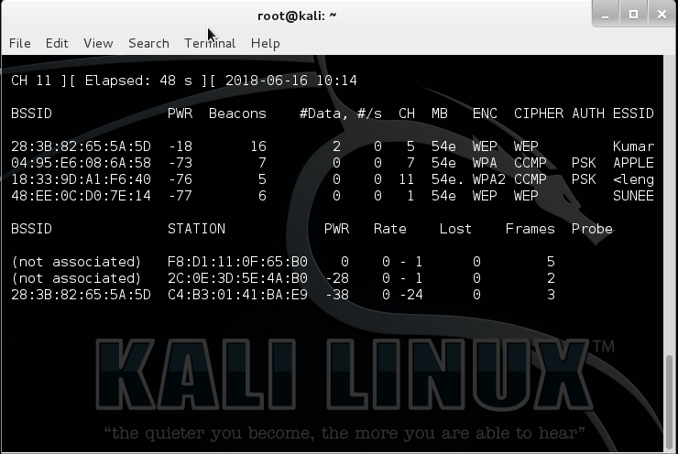

Figure 6-4: capturing data using airodump

The first list shows the Wi-Fi networks within reach of your laptop. The “CH” tells you which channel number each network is using (11, 6, 1 and 11) and the “ESSID” shows the names of the networks (i.e. the service set identifiers). The “ENC” column reveals if the network is using encryption and if so, what type of encryption. The network with ESSID Kumar is selected.

4. Scan and monitor selected networks
Since the wifi that is selected is on channel 5 as seen from Figure 6-4 we are going to capture packets from channel 5 and particularly of bssid 28:3B:82:65:5A:5D.
Use code airodump-ng –w wep –c 5 –bssid 28:3B:82:65:5A:5D mon0
Here:
-w wep is the name of the files that store the captured data.
-c 5 is setting the channel to 5
--bssid 28:3B:82:65:5A:5D is capturing packets to and from the target network.
And mon0 is the monitor mode instance.

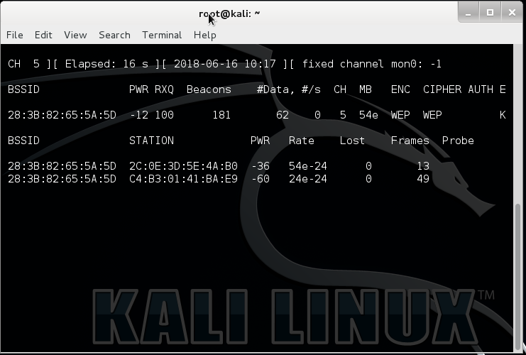

Figure 6-5 : capturing data from particular channel

5. CREATE FAKE TRAFFIC AND CAPUTURE IV
To create fake traffic in the network we can use aireplay suite. First we will be authenticating our machine as one of the devices on the network.
Use code aireplay-ng -1 0 –a 28:3B:82:65:5A:5D –h f8:d1:11:0f:65:b0 –e Kumar –ignore-negative-one mon0
Here,
-1 means fake authentication
0 reassociation timing in seconds
-e Kumar is the wireless network name
-a 28:3B:82:65:5A:5D is the access point MAC address
-h f8:d1:11:0f:65:b0 is our card MAC address

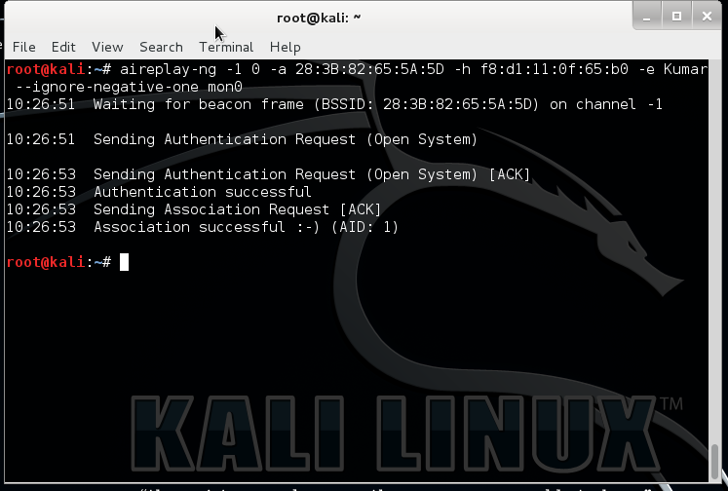

Figure 6-6: fake authentication using aireplay

Now to perform Arp request replay attack use the code aireplay-ng -3 –b 28:3B:82:65:5A:5D –h f8:d1:11:0f:65:b0 –ignore-negative-one mon0.
Here
3 means standard arp request replay
-b 28:3B:82:65:5A:5D is the access point MAC address
-h f8:d1:11:0f:65:b0 is the source MAC address (either an associated client or from fake authentication)

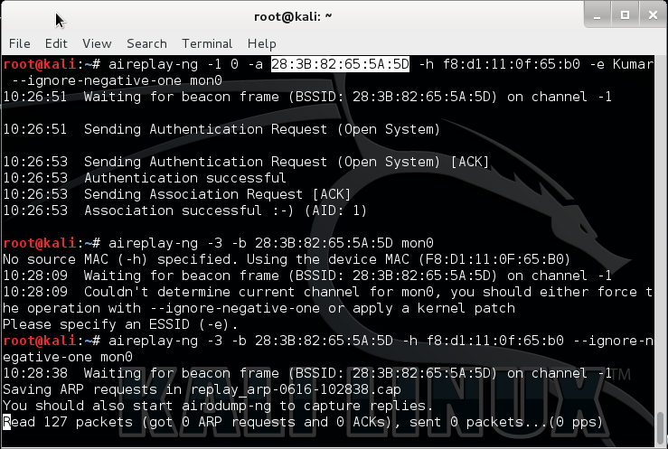

Figure 6-7 : ARP replay request attack.

This attack tries to catch the arp request packets and tries to resend them can be seen in the Figure 6-8. This produces a huge traffic on the network.
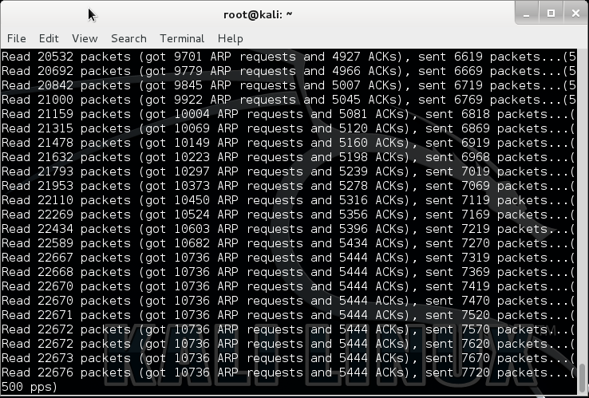

figure 6-8: arp attack in progress.

6. CRACK FOR PASSWORD (MEANWHILE TRY CONNECTING WIFI NETWORK TO GAIN IVs)
The collected data is used to crack the wifi password using aircrack.
Use code aircrack-ng wep-01.cap
Wep-01.cap is the file containing the IVs.
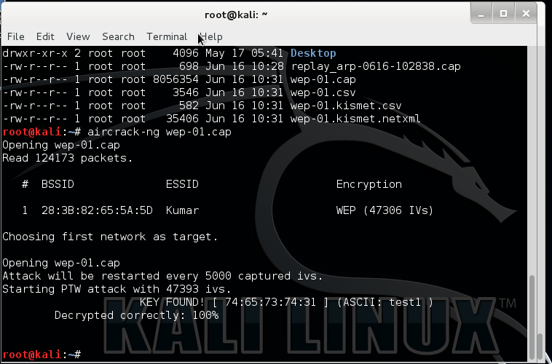

figure 6-9: Cracking password using aircrack.

We can see from the Figure 6-9, it give the cracked password test1 in this case.

